Buttzville United Methodist Church
No Matter where you are in your journey of faith, you are welcome in this place.

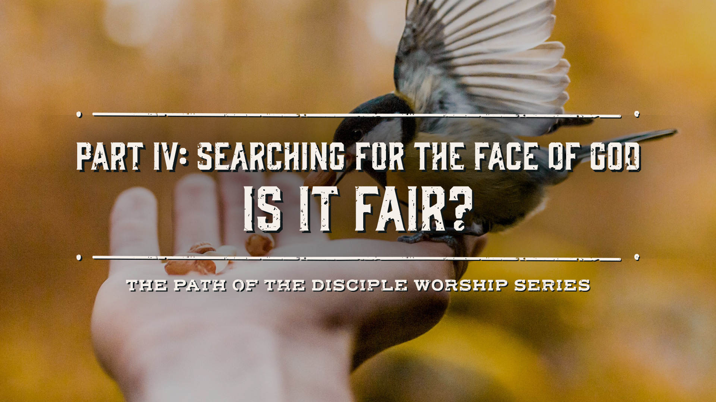

Aug 20th, 2023

Greeting and Welcome
Special Announcements.

*Call to Worship
L: Beloved disciples, welcome! We gather as people reconciled to one another and God through grace, a gift freely and lovingly given that we do not earn or deserve. We receive the marvelous work of grace in our lives, and we wonder, “Is it fair?”
P: No! God’s grace is not fair, but a gift of God’s mercy.
L: We gather as neighbors who have experienced difficulties of every kind. We feel uncertain, fearful, and overwhelmed, and we wonder, “Is it fair?”
P: No! Our difficulties are not fair, and God’s grace meets our uncertainty with mercy and love.
L: We gather as a community that knows the suffering of our neighbors. We look at the effects of poverty, food insecurity, and trauma in our neighborhoods, and we wonder, “Is it fair?”
P: No! The suffering of our neighbors is not fair, and God’s grace calls us to respond to suffering with mercy and justice.
L: We gather as people who question how to live into God’s abundance and flourishing in a world built on scarcity and greed, and we wonder, “Is it fair?”
A: Yes! God’s life of abundance and flourishing is fair, because it is merciful. May God’s grace form us into people of mercy, justice, compassion, and truth-telling as we gather today. Amen.

Praise Song “My Hope Is Built on Nothing Less” UMH 368
Opening Prayer; A: Merciful God, in love You created us, and in love, You sustain us, day after day. We pray for those who are estranged from their spouse or family, Friends, or neighbors; who find it difficult to forgive past wrongs done to them. We pray for those who for years have carried feelings of guilt or regret for something they did or something they neglected to do; who find it difficult to ask for forgiveness or forgive themselves. :Lord sustain all those who look to You in hope. And strengthen us—Your people—so that we may be love for all those who find themselves alone. In the name of Jesus Christ, Amen.

Jr. Sermon

Gospel Reading Matthew 15:10-28

The word of God for the people of God. Thanks be to God. Amen!

Message “God is Not Fair!” Pastor Scott

Praise Song (to be picked by Mary as moved by the Holy Spirit)

Celebrations of God’s Grace and Christ encounters in our lives
Prayers and Concerns of the People, Pastoral Prayer
The Lords’ Prayer UMH 895

Tithes and offerings.
Doxology UMH 94

Offering Prayer: A: Creator and architect of the universe, we want to believe that your love for us means you will go before us on life’s path and clear the way, making it easy to travel, but our experience doesn’t always bear that out. We know you see a bigger picture than we do. As we bring you our offerings this day, we affirm your presence with us in the pits of despair as well as in the palaces of plenty. We give with gratitude, in Christ’s holy name. Amen. (Gen 45:1-15)

Praise Song “Standing on the Promises” UMH 374

Benediction

Postlude
Our Worship has ended—now our Service Begins
“Do all the good you can, by all the means you can, in all the ways you can, in all the places you can, at all the times you can, to all the people you can, as long as ever you can.”
– John Wesley, Founder of Methodism

A warm welcome is offered you this morning in the name of Jesus Christ. We are glad you have joined us for worship. If you are searching for a church home, we hope you will consider Buttzville United Methodist, where we seek to help one another grow in faith, in love, and in service.

Check us out on facebook for upcoming events or our website www.buttzvillechurch.org

Thought for Reflection: When we are truly seeking the face of God, we go beyond fair and move into grace manifested in love in all our relationships.
